Data Operations - Visualizing

Definition
# Source: AI Source: Provided by: [Data Path: Persons Table -> ID Column: 1, Name_En Column: Motasem Essam] -> From: [Chatgpt (GPT‑5 Mini)] on [12/10/2025]
Data Visualization is the process of representing data using graphs, charts, plots, or visual elements to make information easier to understand, analyze, and interpret.

Key Idea
# Source: AI Source: Provided by: [Data Path: Persons Table -> ID Column: 1, Name_En Column: Motasem Essam] -> From: [Chatgpt (GPT‑5 Mini)] on [12/10/2025]
Humans understand visual patterns much faster than raw numbers. Visualization helps reveal trends, patterns, relationships, and outliers in data.

How It Works
# Source: AI Source: Provided by: [Data Path: Persons Table -> ID Column: 1, Name_En Column: Motasem Essam] -> From: [Chatgpt (GPT‑5 Mini)] on [12/10/2025]
- Prepare and clean the dataset.
- Choose an appropriate visualization type based on the data.
- Plot the data using visualization tools or libraries.
- Interpret the visual output to gain insights.

Common Types of Visualizations
# Source: AI Source: Provided by: [Data Path: Persons Table -> ID Column: 1, Name_En Column: Motasem Essam] -> From: [Chatgpt (GPT‑5 Mini)] on [12/10/2025]
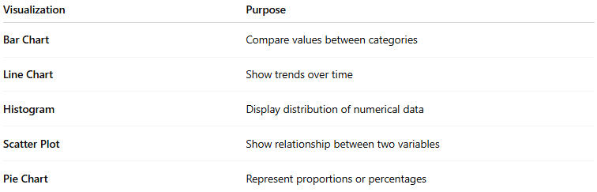
Visualization | Purpose
Bar Chart | Compare values between categories
Line Chart | Show trends over time
Histogram | Display distribution of numerical data
Scatter Plot | Show relationship between two variables
Pie Chart | Represent proportions or percentages

Example
# Source: AI Source: Provided by: [Data Path: Persons Table -> ID Column: 1, Name_En Column: Motasem Essam] -> From: [Chatgpt (GPT‑5 Mini)] on [12/10/2025]
Dataset: Sales by Product
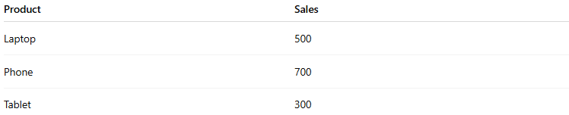
Product | Sales
Laptop | 500
Phone | 700
Tablet | 300
Bar Chart Visualization would show each product on the x-axis and sales on the y-axis to easily compare performance.

Applications
# Source: AI Source: Provided by: [Data Path: Persons Table -> ID Column: 1, Name_En Column: Motasem Essam] -> From: [Chatgpt (GPT‑5 Mini)] on [12/10/2025]
- Exploratory Data Analysis (EDA)
- Identifying patterns and trends
- Communicating results in reports and dashboards
- Supporting data-driven decision making

Advantages
# Source: AI Source: Provided by: [Data Path: Persons Table -> ID Column: 1, Name_En Column: Motasem Essam] -> From: [Chatgpt (GPT‑5 Mini)] on [12/10/2025]
- Makes complex data easy to understand
- Highlights patterns and relationships
- Improves communication of insights

Disadvantages
# Source: AI Source: Provided by: [Data Path: Persons Table -> ID Column: 1, Name_En Column: Motasem Essam] -> From: [Chatgpt (GPT‑5 Mini)] on [12/10/2025]
- Poorly designed visuals can mislead interpretation
- May oversimplify complex datasets
- Requires careful selection of chart types

